Long Distance Multi Sensor Thermal Camera
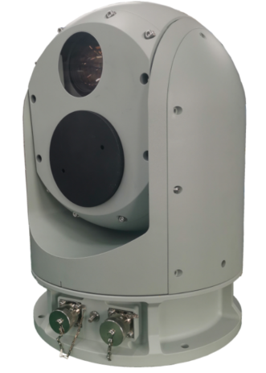

Z201 Series Long Range Multi Sensor Thermal Camera integrates HD daylight camera, uncooled thermal camera, gyro stabilization, intelligent analysis, and precise electronic control. It is designed for ship /shipboard video acquisition and sea surface warning, key target warning, radar linkage and other applications designed long distance detection system, which can adapt to all-weather, all-time, full-dimensional discovery, positioning, tracking, identification and tracking of the target function, the smallest distance to small ships and islands can be up to 10 km.

Feature
1.Multi spectrum: Integrated with HD daylight camera system, uncooled sensor thermal camera system,, and so on. Combined with active and passive detection, 24 hours surveillance in all-weather environments.
2.High/Fast turning speed: turning speed 90°/s, acceleration 120°/s², helpful for capture and tracking fast moving targets.
3.Wide coverage: the azimuth rotation range is 0~360°, and the pitch rotation range is -90° ~+90°, all angle detection, all-round coverage.
4.High control accuracy: using precision angle encoder and high precision servo PT control system, the positioning accuracy can reach 0.02°, high performance imaging processing technology combined with high precision focus control to achieve precise auto focus.
5. Excellent tracking performance: The automatic tracking module is designed with a variety of target acquisition algorithms and tracking algorithms, supplemented by high-precision servo control, to ensure stable tracking of the target during rapid movement and process.
6.Gyro stabilization: The two-axis gyro stabilization structure design effectively isolates the disturbance of the optical system caused by carriers such as vehicles and ships, and always maintains a high degree of image and video stability.
7. Intelligent analysis: Support target intrusion detection, motion detection and other abnormal behavior detection, support target classification and identification, support hot spot alarm, radar linkage, 3D zoom positioning and other functions.
8. Self-diagnosis and self-recovery: support life-cycle management, fault self-checking, front-end storage, resuming transmission after disconnection, memory after power failure, remote restart/upgrade.
9. Environmental adaptability: high-strength aluminum alloy material, internal and external double-layer three-proof technology, IP67 protection, rain-proof, dust-proof, anti-corrosion, anti-electromagnetic interference

Application
Border/Costal defense, harbor, oil field, river lane, airport, safe city
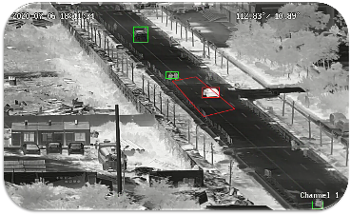
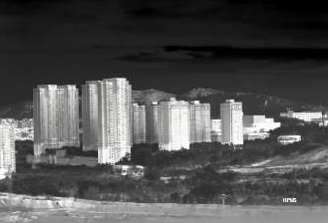
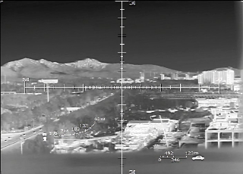
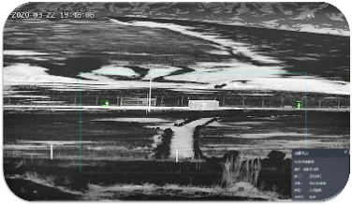
Auto Track Intrusion Detection High Resolution Ranging Scale
Technical specification
Model | HP-Z201-LFZ
Detection | Thermal: Vessel: 10km; Vehicle: 3km; Human:1.2km
Detection | Daylight: Vessel: 20km; vehicle:5km; Human: 2.5km
Thermal Camera System
Detector | Uncooled sensor
Pixel size | 12μm
Resolution | 640*512 resolution (1280*1024 resolution for option)
NETD | 40MK
Lens | 25~100mm
Zoom | 4X optical zoom, 8X digital zoom
Lens control | Electric zoom; manual/auto focus, 3A adaptive active focus algorithm, support multiple trigger modes
Image process | SDE digital image enhancement technology, enhance the details of the image, support 255 enhancement adjustment
Pseudo-color | 16 kinds of pseudo-color images, hot black / hot white two polarities
Image parameters | AGC automatic gain control, brightness, contrast
Digital zoom | 1x~8X continuous digital zoom, support global synchronous display
Range Scale | Support range scale to measurement the distance
Strong light protection | Support anti-sun damage
Daylight Camera System
CMOS | Ultra-low illumination starlight CMOS
Low Illumination | Color: 0.005lux, black/white: 0.001 lux
Lens | 6mm~210mm, 35X zoom
Image process | Support white balance, electronic shutter, backlight compensation, strong light suppression, 2D/3D digital noise reduction, electronic image stabilization, WDR, heat wave drift suppression
Defog | Support
Audio/Video
Thermal Resolution | Support: 1920×1080；1280×1024；1280×960；1024×768；1280×720；704×576；640×512；640×480；400×300；384×288；352×288；352×240
Daylight Resolution | Support:2592×1520；2560×1440；1920×1080；1280×1024；1280×960；1024×768；1280×720；704×576；640×512；640×480；400×300；384×288；352×288；352×240
Video encoding | H.265/H.264/MJPEG
Video bit rate | 32Kbps～16Mbps
OSD setting | Support OSD display settings for channel name, time, gimbal orientation, field of view, focal length, and preset bit name settings
Intelligent Functions
Intelligent analysis | support intrusion detection, boundary crossing detection, entering/leaving area detection, motion detection, wandering detection, people gathering, fast moving, target tracking, items left behind, items taken; people/vehicle target detection, face detection; and support 16 area settings; support intrusion detection people, vehicle filtering filtering function; support target temperature filtering filtering function
Auto Track | Support
Enhanced Features
Distance measurement | Support passive distance measurement; support optional laser distance measurement.
Anti-Sunburn | Support
Temperature correction | A thermalization design, image clarity is not affected by temperature
Disconnection renewal | Support
Power failure memory | Support can restore the position before power failure, preset point state, cruise state, line sweep state
Web access | support WEB full function configuration, remote online upgrade
Pan Tilt
Structure | Dome model, wind resistance, strong anti-shake, can resist 12-level strong wind
Gyro stabilization | two-axis gyro stabilization
Rotation | N*360°in horizontal, -90~+90 in pitch
Rotation Speed | 0.01°～90°/s in horizontal, 0.01°～90°/s in pitch
Acceleration | 120°/s² (horizontal and pitch)
Positioning accuracy | ≤ 0.02°
Preset | 3000
Gyro stabilization | Support, two axis gyro stabilization
Interface
Network interface | RJ45
Network Protocol | Support HTTP，HTTPS，FTP，SMTP，DNS，NTP，RTSP，RTCP，RTP，TCP，UDP，ICMP，DHCP；ONVIF,GB28181 and so on
Physical interface | alloy waterproof aviation plug
Others
Power supply | DC24V with power adapter
Power consumption | Normal: ≤ 150W; Peak: ≤ 400W
Working temperature | -40 ~+ 60℃
Storage temperature | -45 ~+ 70℃
Humidity | <90%
Ingress protection | IP67
Weight | ≤ 20kg
Dimension | 280mm*400mm
Display and Monitor
Display | 1.Screen: 10 inch, 16:9
 | 2.Resolution: 1920*1080
Function | FOV/Focus/Video/PIP/Self-checking/Target check/Auto track/Gyro stabilization/Manual track/
Interface | - Communication: 2ch RS422;2 channel USB  - Video: RJ45
Dimensions/Weight | Dimensions: 300*260*65mm Weight: 5kg
